**Install Eclipse+Pydev on Windows 7**

Author: Kai-Tao Yang ([k.t.yang@uvt.nl](mailto:k.t.yang@uvt.nl)), Data Engineer at JADS

Eclipse is a popular Integrated Development Environment (IDE) for many programming languages (e.g., Python, Java, JavaScript, C/C++). Here, we are going to install Eclipse as IDE for Python in two steps: (1) install Eclipse; (2) install Pydev, which is an add-on of Eclipse for Python.

# Install Eclipse

Install Eclipse which can be downloaded from <https://www.eclipse.org/downloads/>

# Install Pydev

1. **Click** Help🡪Install New Software
2. **Copy paste** the following link to the Work with, **check** Pydev and PyDev Mylyn Integration, **click** next.

<http://update-production-pydev.s3.amazonaws.com/pydev/updates/site.xml>

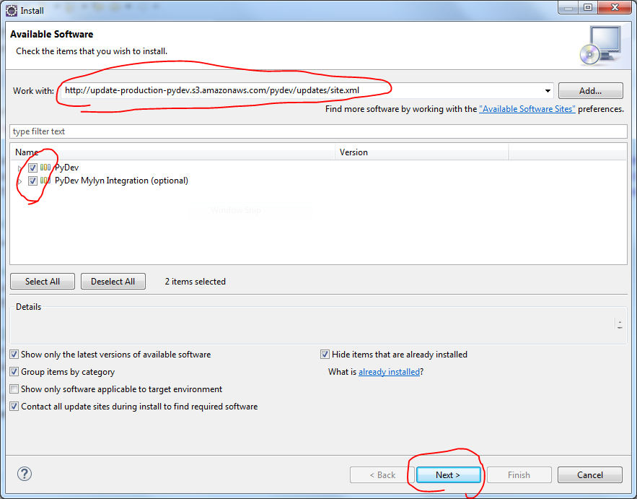

# Test

1. Check whether Python has been installed by run the command ‘Python’ in the terminal, if you already installed Python, then you will see the following figure (it can be seen that **Python 3.5.1** has been installed on my computer):

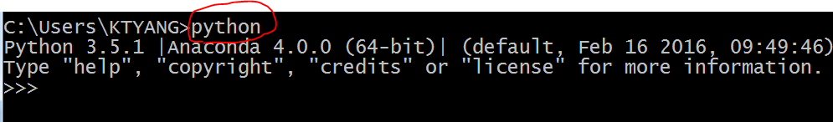

1. If Python is not installed yet, please install Anaconda according to the document <Jupyter environment establishment.docx>, after installing Anaconda, you will have Python installed automatically.
2. If Python is installed, then launch eclipse:

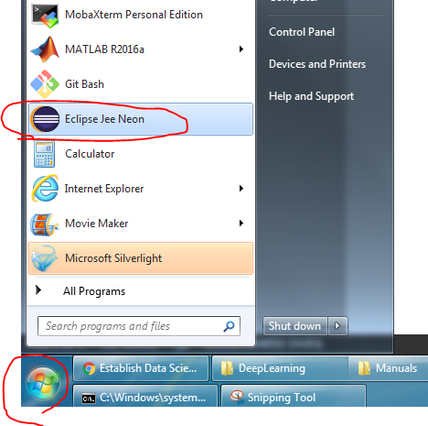

1. **Click** file🡪Other, **select** the Pydev Project, and **click** Next.

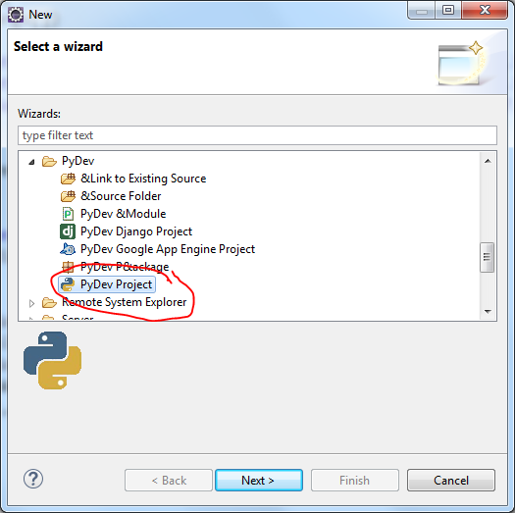

1. **Type** in the Project name (e.g., helloworld), **Select** the Grammar Version (Python 2.7 or Python 3.0-3.5, I selected Python 3.0-3.5 because I have Python 3.5.1 installed), Click here to configure an interpreter not listed.

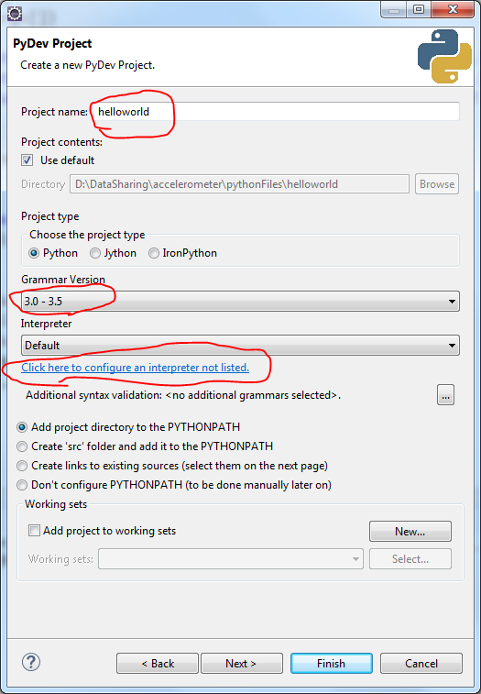

1. Click Quick Auto-Config and ok.

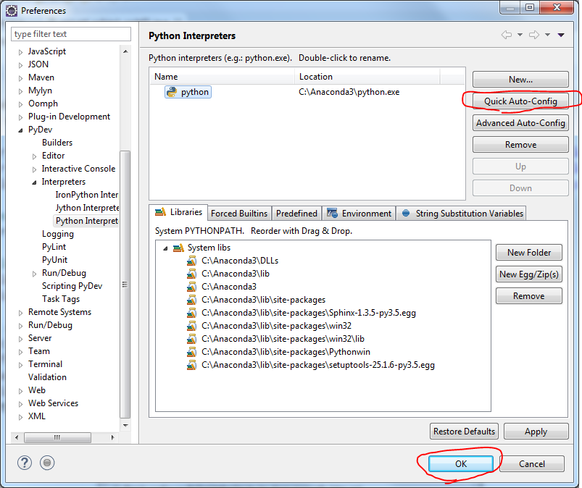

1. Click Finish and Yes.

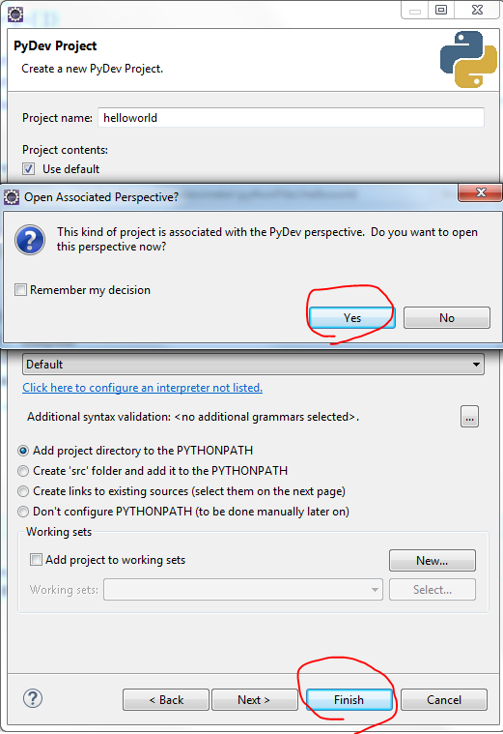

1. **Right click** your project (e.g., helloworld as show below), **click** New, **click** PyDev Module.

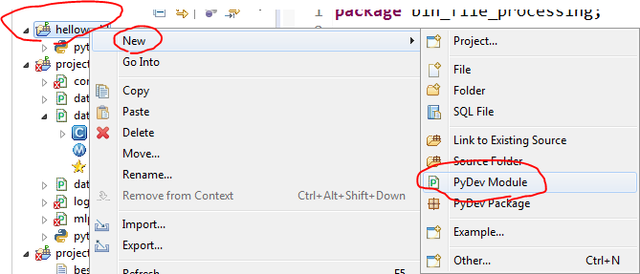

1. **Type in** the Name (e.g., hello), and click Finish.

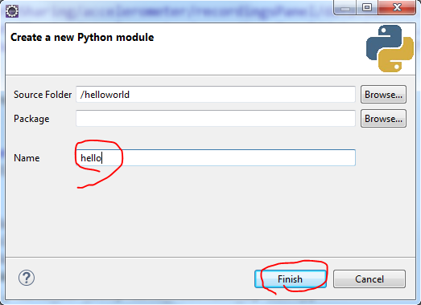

1. Click <Empty> and ok.

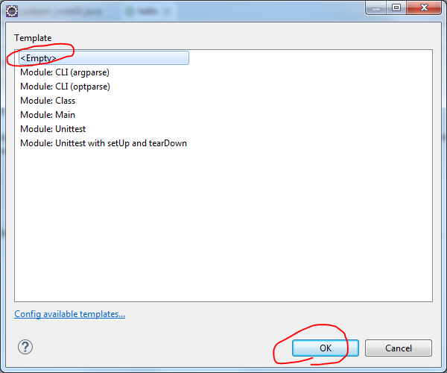

1. Type in:

print("hello world!")

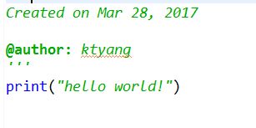

1. **Press** Ctrl+F11 to run the code, **select** Python Run, **click** ok.

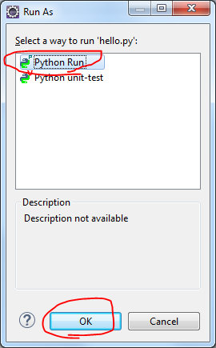

1. If you see “hellow world!” is printed in the Console, it means that you install Eclipse+Pydev **successfully**.

